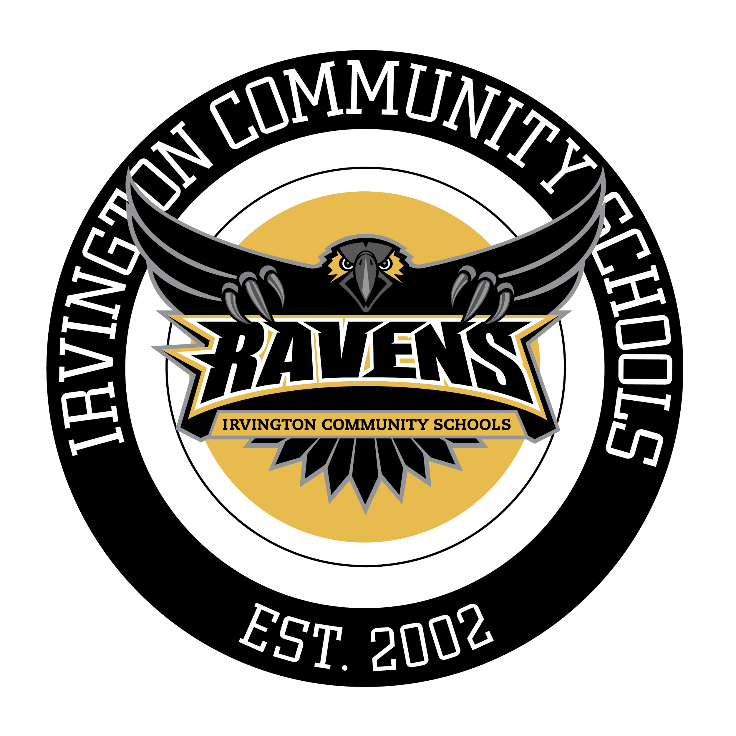

Scavenger Hunt
Irvington Community Schools will be hosting a free scavenger hunt for the community, students, parents, friends, alumni, board members and more to participate in. This brings everyone back together to experience family fun in a safe and engaging way with the community of Irvington.

The hunt will be encompassing many different skills and tactics starting with social media, newsletter promotions, press releases, pitch letters, sponsor letters, thank you cards and more. Not only will a scavenger hunt provide family fun around the Halloween season, but it will also be a great way to promote ICS throughout the community and on social media. The participants must take a photo with each location for proof at the end of the competition. There will be no need for them to post on social media to win, but if they enjoy the photos enough, they will be more inclined. The first team to complete the hunt correctly with photos at each location will be the winner. Winners receive a goody bag with special gift cards to participating locations from scavenger hunt. Groups may not extend six members. If noticing more than six members in group, they will not be crowned winner.

Tactics (that could be included):

Saturday, October 27, 2018 @ 4:00pm
Start: Irvington United Methodist Church
End: Irvington Preparatory Academy Gymnasium
- Pizza Party afterwards in the Gym/Cafeteria of Prep Academy
- $5 Two Slices and Water

Rules

Places included in the Scavenger Hunt:
- Irvington United Methodist
- Jockamo’s Pizza
- Wyliepalooza Ice Cream
- Irving Theatre
- Irvington Presbyterian Church
- Black Sheep Gifts
- Irvington Vinyl
- Irvington Public Library
- Coal Yard Coffee Shop
- Irving Circle Park
- Irvington Preparatory Academy

CLUES
Clue to Jockamo’s Pizza: Not far of a drive, we’re home of the Slaughterhouse 5.
Clue to Wyliepalooza Ice Cream: Here you can party all of the time, our Super Premium, will taste simply divine.
Clue to Irvington Public Library: We have romance, we have thrillers, but when you're reading here, we promise no killers.
Clue to Irving Theatre: In 1913, we opened our doors. People claim we’re haunted, the House of Horrors.
Clue to Black Sheep Gifts: We can take you from cradle to grave, come purchase a gift, if you’re brave.
Clue to Irvington Vinyl: Can you hear the sounds of the spooky night? Come on in, we’ll try not to give you a fright.
Clue to Irvington Presbyterian Church: We’re located just south of here, waiting to embrace you with love and definitely not fear.
Clue to Coal Yard Coffee: Dark Roast or Light Roast, no matter your order, you will spot a ghost!
Clue to Irving Circle Park: Located on Audubon and University, we’re not that scary. We’re always open to diversity!
Clue to Irvington Prep: One last clue and you’re through – Can you make it back to Prep school?

Helpful Links
https://matadornetwork.com/life/how-to-organize-a-citywide-scavenger-hunt/
http://www.spandainc.com/pdf/scavenger-rules.pdf
http://www.fundraiserinsight.org/articles/scavenger-hunt-fundraising.html
http://www.discoverirvington.com/
http://www.indy.gov/eGov/City/DMD/IHPC/Districts/Historic/Pages/irvington.aspx
http://www.irvingtonhalloween.com/irvington-ghost-tours
http://indianaghosttours.org/

